**Users and Authorization Groups**

1. Go to User Management and select your user
2. Then go to User Authorizations and filter by your user
3. Check the authorization group
4. Then filter by the corresponding authorization group

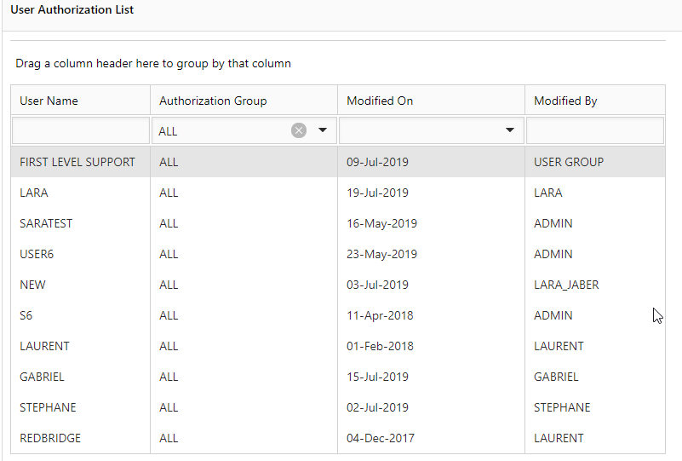

1. To add new user to the list, select the user from the above list and add him to the needed group

